Great prosperity vs. Great Regression

- What is the Ideological perspective of the source – what values are reflected?

- Who would agree with the perspective? Why?

- Who would disagree with the perspective? Why?

- Based on your knowledge and infered from the sourcewhat are some monetary and fiscal policies that could be used to avoid the Great Regression?

- Based on your knowledge and infered from the source what are some monetary and fiscal policies that could have ccontributed to the Great Regression?
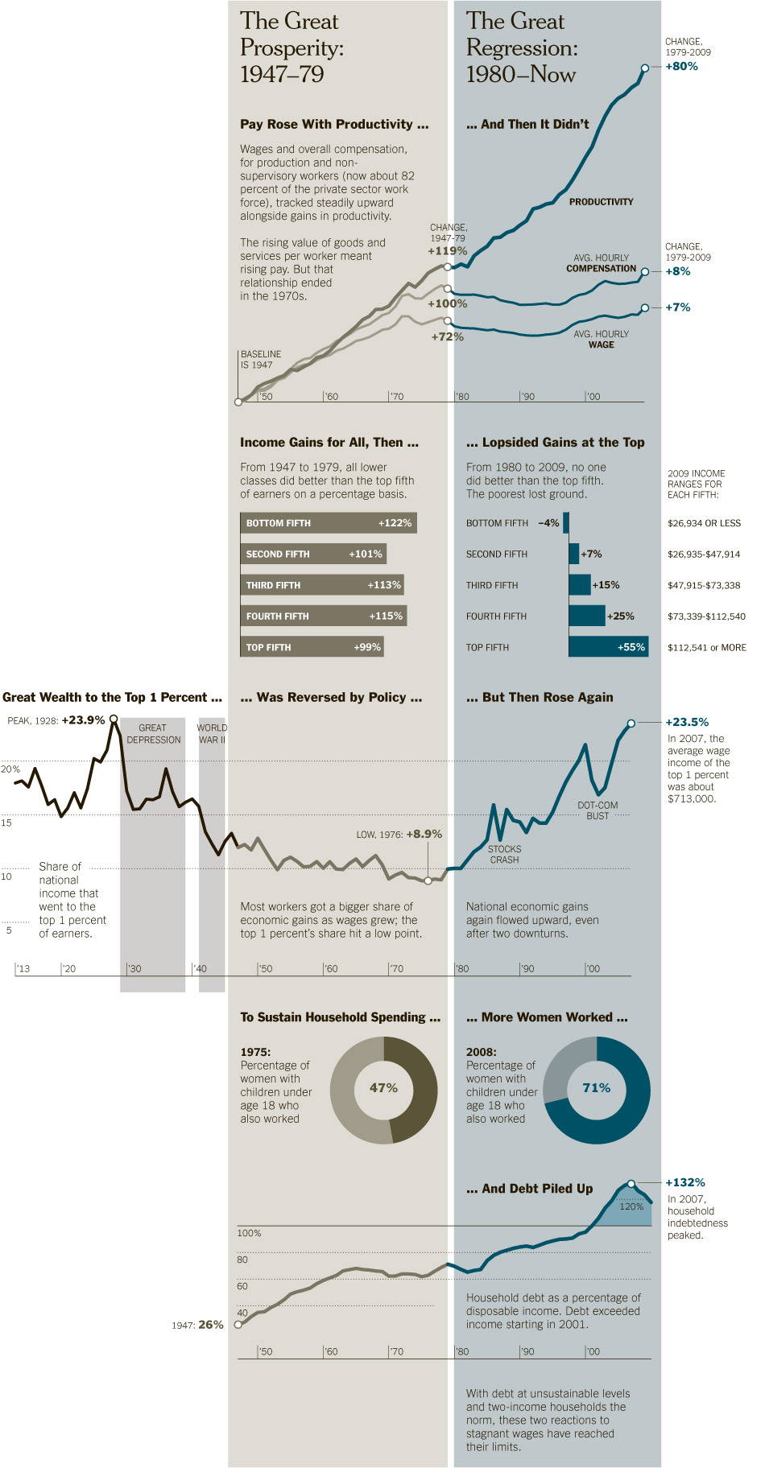http://www.nytimes.com/imagepages/2011/09/04/opinion/04reich-graphic.html?ref=sunday

